Taking selfies and inserting yourself in celebrity scenes

Objectives
1.1- apply techniques and procedures needed to manipulate images in a range of digital media.
1.3- demonstrate an awareness of the procedures involved in the production of images.
1.4- apply principles of art and design to create digital and electronic images.
1.5- construct digital and electronic images which communicate ideas and concepts.
Over view of the project

Take a self portrait of yourself and use adobe Photoshop and place yourself in a shot with a celebrity or in a sports setting
- A list of objectives
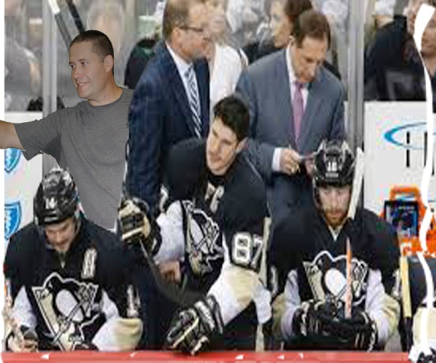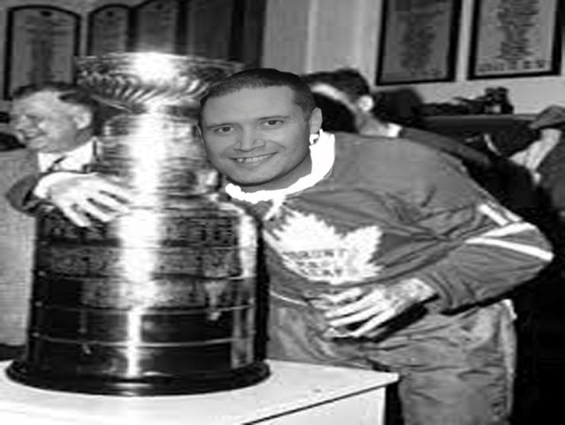

Step 1
Step 1: select a photo to insert yourself in using Google. Save it as a jpg.
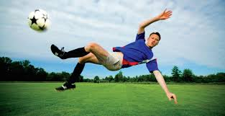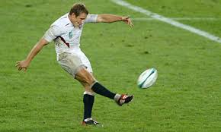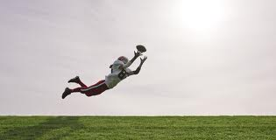

Step #2: Take a photo of yourself mimicking the pose you want to recreate or use to add yourself to the photo.

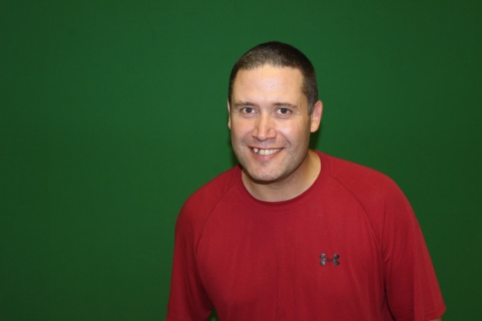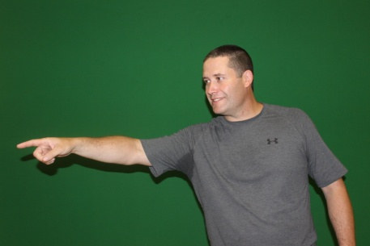

Step #3: Open adobe Photoshop, select file, new and set the dimensions to 800x600 pixels.

Step#4: open the picture of the scene you are going to insert yourself into, and then open your selfie picture as well.

Step #5: Use the rectangle surround tool and select your celebrity picture and edit copy, then use as a background, drop that on your new canvas that you selected in step # 3 by selecting paste then shift and stretch your photo out to fill the canvas
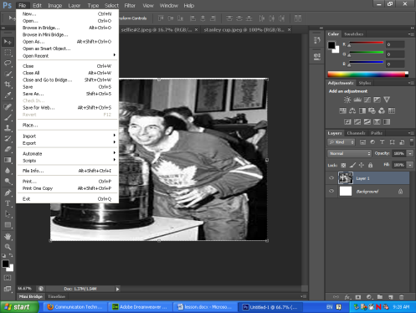

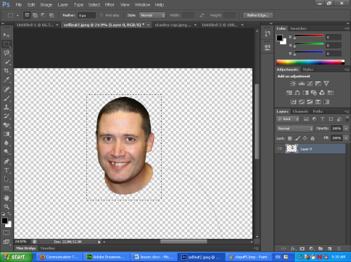
Step #6: Open up selfie and use the magic eraser and majic wand and select the parts of your selfie you want to add as selfie, then select with rectangle tool and edit copy.

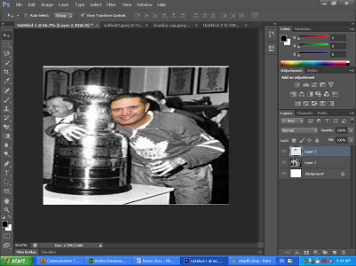
Step #7: paste the photo in your celebrity shot as a layer and position using transitions.

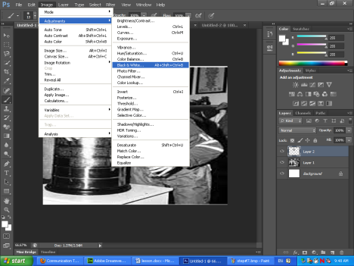
Step #8: Use the dropper, paintbrush etc to fix any details to blend yourself. Then use the image tab and select any adjustments needed for brightness etc.

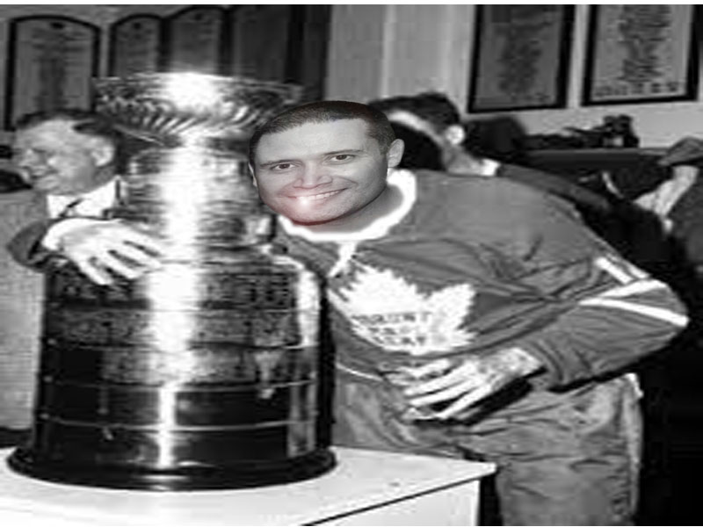
Step #9: Adjust any lighting in Image, layer or Filter. In this one I added a lens flare and changed the selfie to black and white and adjusted the lighting effects in Filter, render, lighting effects. Make any

Multimedia Project : Creating a Selfie with a Celbrity

Teacher Name: Mr. Murphy
Student Name: ________________________________________

CATEGORY | 4 | 3 | 2 | 1
selection of selfie pose | Students Pose matches perfectly with the celebrity picture | Students Pose matches close with the celebrity picture | Students Pose matches somewhat with the celebrity picture | Students Pose does not match with the celebrity picture
Layering of selfie | Students does a great job selecting the background and cutting the pose and layering unto backdrop | Students does a good job selecting the background and cutting the pose and layering unto backdrop | Students does an okay job selecting the background and cutting the pose and layering unto backdrop | Students does a poor job selecting the background and cutting the pose and layering unto backdrop
layering | student sizes and layers his picture with great skill using transitions and positioning | student sizes and layers his picture with good skill using transitions and positioning | student sizes and layers his picture with okay skill using transitions and positioning | student sizes and layers his picture with poor skill using transitions and positioning
paint and | student does a great job using paint brush and other effects to adjust the lighting, brightness, filters and adds appropriate effects | student does a good job using paint brush and other effects to adjust the lighting, brightness, filters and adds appropriate effects | student does a okay job using paint brush and other effects to adjust the lighting, brightness, filters and adds appropriate effects | student does a poor job using paint brush and other effects to adjust the lighting, brightness, filters and adds appropriate effects
finished product | the finished picture looks great and is saved in the proper JPEG format | the finished picture looks good and is saved in the proper JPEG format | the finished picture looks okay and is saved in the proper JPEG format | the finished picture looks poor and is saved in the proper JPEG format

