6th Grade Final Assessment of Learning
Multiple Choice: Record your answers on the answer sheet provided.
1. Sam and Sarah came up with an experiment to test whether their dog preferred the new brand of dog food compared to dog food currently being used. Sarah placed two new, identical bowls side by side on the kitchen floor. Sam held the dog from across the room. Sarah poured equal amounts of each brand of dog food into the bowls, and Sam released the dog. What type of experiment did Sam and Sarah set up?
a. investigational
b. discovery
c. controlled
d. variable
2. A hare (rabbit) has eyes on the side of its face to allow it to see predators. What type of survival strategy is this?
  - Defense mechanism
  - Symbiosis
  - Migration
  - Predation

3. According to the relationship in the above graph, the wolf would be considered:
- the predator
- the prey
- the limiting factor
- an herbivore
4. In an ecosystem a rabbit that feeds on grass would be considered
- a primary consumer
- a secondary consumer
- a tertiary consumer
- a producer
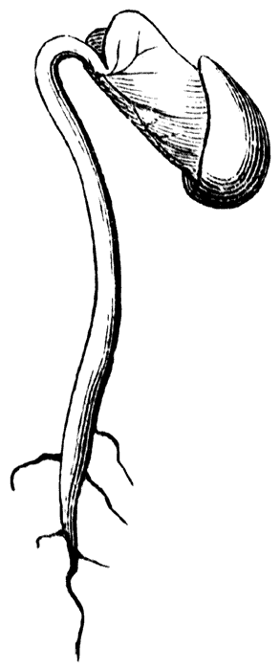
5. The drawing below shows a plant during the early development stage in its life cycle. Under normal conditions, which of the following will occur next as the plant continues to grow?
a. Fruits and roots will develop.
b. Seeds and stems will develop.
c. Stems and leaves will develop.
d. Flowers and fruits will develop.

6. Which part of the flower is responsible for producing pollen?
a. Petal
b. Stamen
c. Pistil
d. Sepal
7. How does photosynthesis help plants to survive?
a. it helps the plant to reproduce
b. it helps the plant make pollen
c. it is the main source of food energy for the plant
d. it provides the plant with carbon dioxide
8. A group of different types of cells work together to form a tissue. What does a group of different tissues working together form?
a. cells
b. tissues
c. organs
d. organ system

9. A student notices that leaves do not build up and make large piles in the forest year after year. Which kingdom of living things is responsible for breaking down dead organisms and return important nutrients to the environment?
a. plants
b. animals
c. protist
d. fungi

10. Felis concolor is the scientific name of a mountain lion. Which classification levels made up this name?
a. kingdom and phylum
b. class and order
c. genus and family
d. genus and species

Bacteria

11. In the diagram above, which organisms obtain energy for growth and development directly from the Sun?
- Caterpillars
- Frogs
- Hawks
- Bean Plants

12. In the diagram above, which organism correctly completes the food web?
- Horses
- Mice
- Bacteria
- Trees

13. Which process produces oxygen that is released into the atmosphere?
a. respiration
b. excretion
c. locomotion
d. photosynthesis

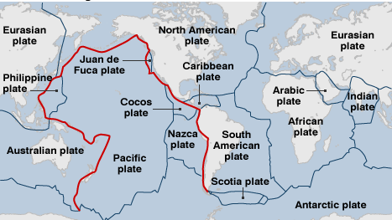
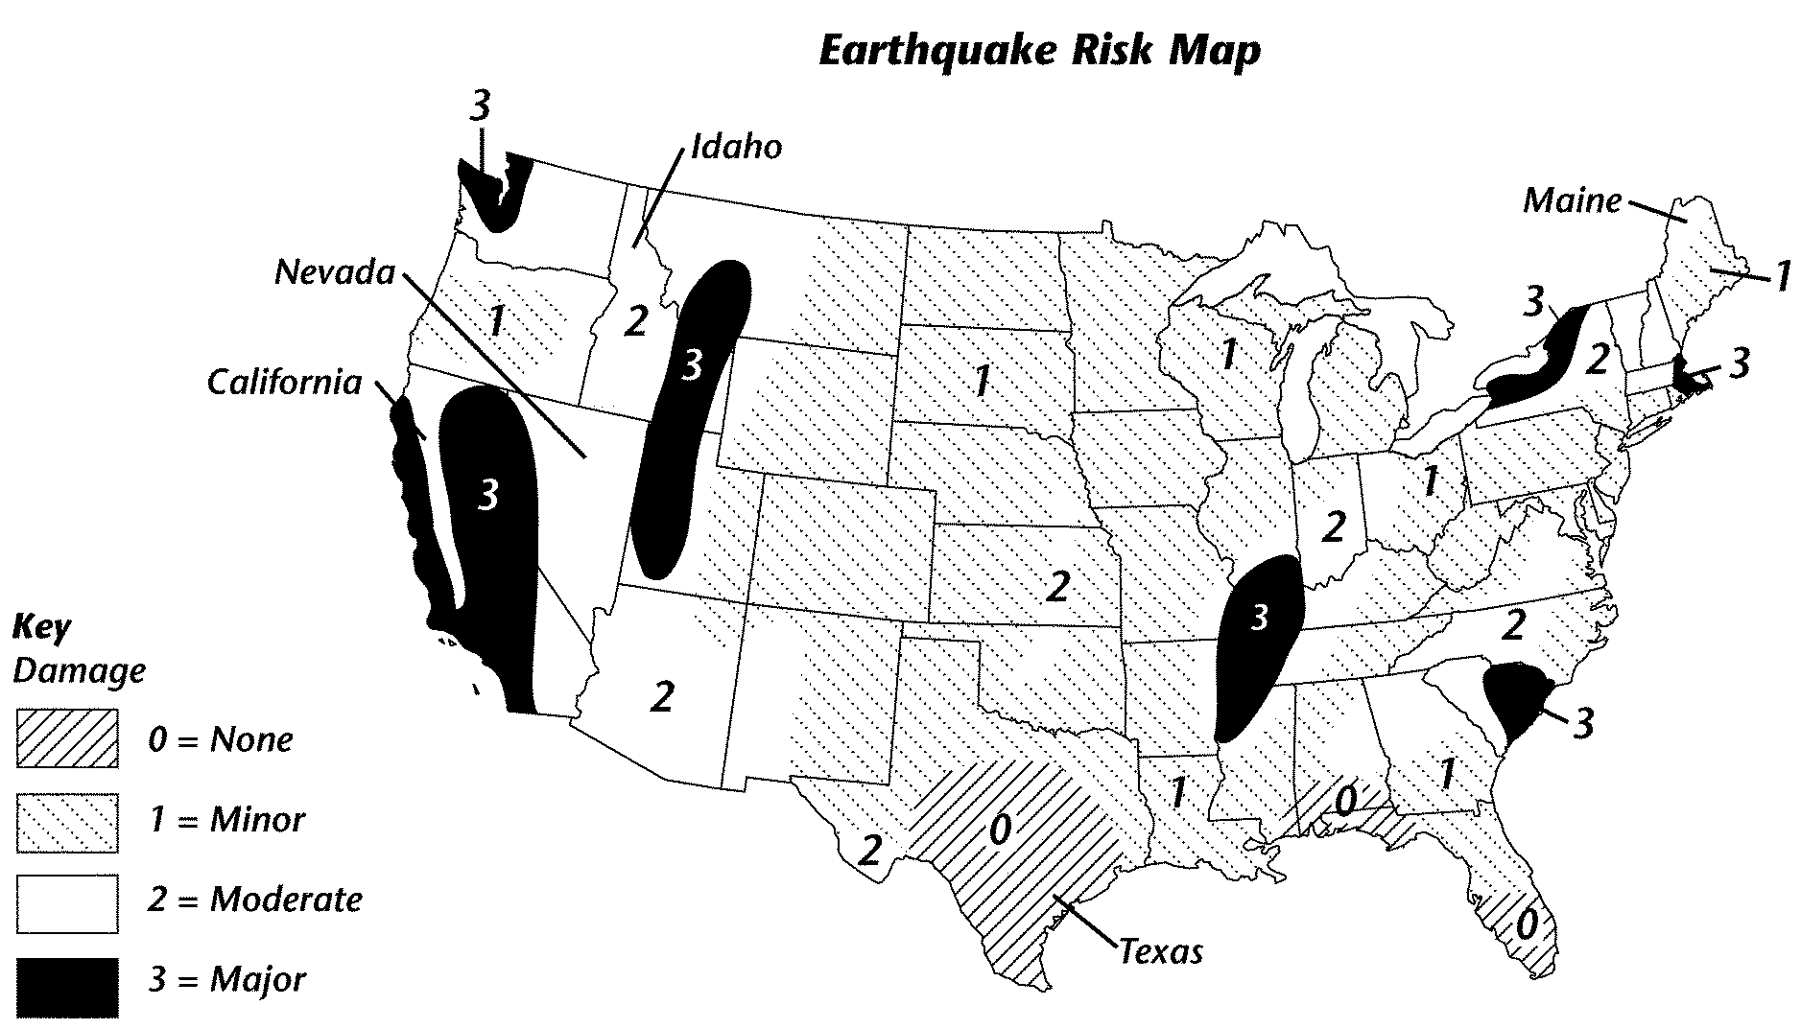

B
A
14. What is the risk level of an earthquake in Southern Texas?
  - none
  - minor
  - moderate
  - major
15. Looking at Picture B, what is the area surrounding the Pacific Ocean called?

- San Andreas Fault
- Mid-Ocean Ridge
- Ring of Fire
- Great Ocean Basin

16. Looking at both Pictures A and B, why isn’t there much seismic activity along the Eastern Coast of North America?

- It is not located near a plate boundary.
- It is too far north of the equator.
- It is not near the San Andreas Fault.

Constructed Response
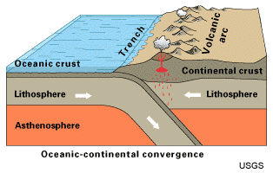
17. Use the diagram below and describe how a volcano forms.

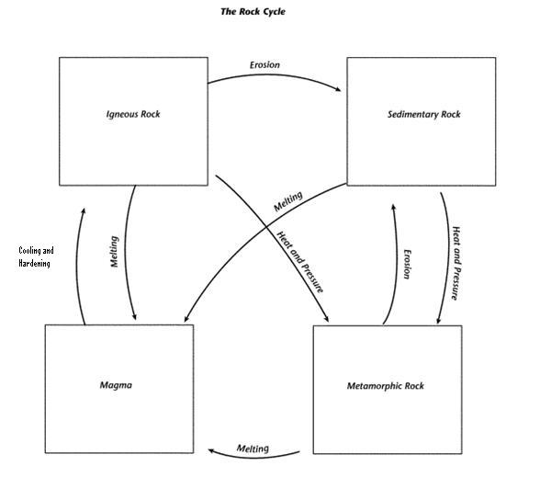
18. Rock that forms from the cooling and hardening of magma is called
- sedimentary rock
- metamorphic rock
- igneous rock
- coarse-grained rock
19. Erosion leads to which type of rock?
- sedimentary rock
- metamorphic rock
- igneous rock
- coarse-grained rock
20. What leads to the formation of metamorphic rock?
- erosion
- melting
- volcanic activity
- heat and pressure

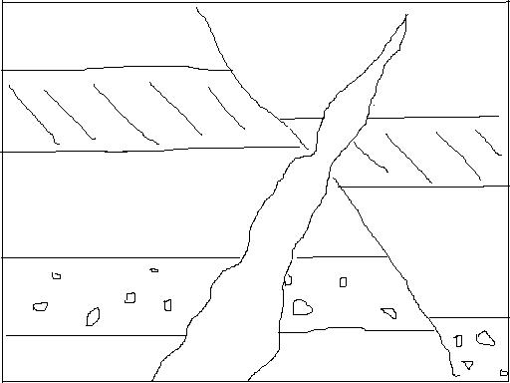
21. Which of the following layers of rock is most likely the youngest?
1
- Layer 1
- Layer 2
2
- Layer 3
- Layer 4
3

4

Constructed Response
22. Describe a pathway through the rock cycle in which magma becomes a sedimentary rock.

B
A

23. What scientific principle does picture A show?
  - gravity
  - speed
c
  - Doppler Effect
  - velocity

24. Sound waves are an example of what type of waves?
a. longitudinal (push – pull)
b. transverse
c. R waves
d. Surface waves

25. Which person in Picture A hears a higher pitch?
a. Location A
b. Location B

26. In which location of Picture A above would the pitch stay the same?
a. Location A
b. Location B
c. Location C

27. What would be needed to increase the strength of the electromagnet in the picture below?
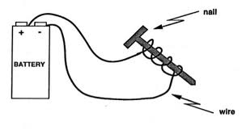
a. longer wire
b. more coils
c. aluminum nail
d. glass insulator

Short Constructed Response:

28. What role does frequency and wavelength play in the pitch of a sound?

Name ________________________________ Period ____ Date _______
6th Grade Final Assessment of Learning
Record your answers to the multiple choice and short-constructed response questions in the spaces below.
1. _____
2. _____
3. _____
4. _____
5. _____
6. _____
7. _____
8. _____
9. _____
10. _____
11. _____
12. _____
13. _____
14. _____
15. _____
16. _____

18. _____
19. _____
20. _____
21. _____

23._____
24. _____
25. _____
26. _____
27. _____

17._______________________________________________________________________________________________________________________________________________________________________________________________________________________________________________________________________________________________________________

28._______________________________________________________________________________________________________________________________________________________________________________________________________________________________________________________________________________________________________________
22._______________________________________________________________________________________________________________________________________________________________________________________________________________________________________________________________________________________________________________

